|  |
| --- |
|  |
| GeoInfo Access Help Documentation |
| Programmed by |
|  |
| **Jason Chalom** |
|  |

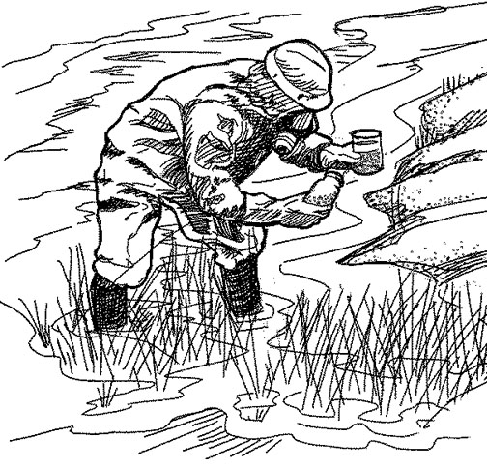

|  |
| --- |
|  |

Table of Contents

1. Login 2

2. Select Data Tasks 4

3. Export Data to File 5

4. Close Data 7

5. Add Data 8

a. Survey Data 8

b. Add Database Value Data 10

6. Export User List To File 11

7. Preferences 12

a. Add A New User 13

b. Change the current user’s password 13

8. Troubleshoot **Error! Bookmark not defined.**

# Login

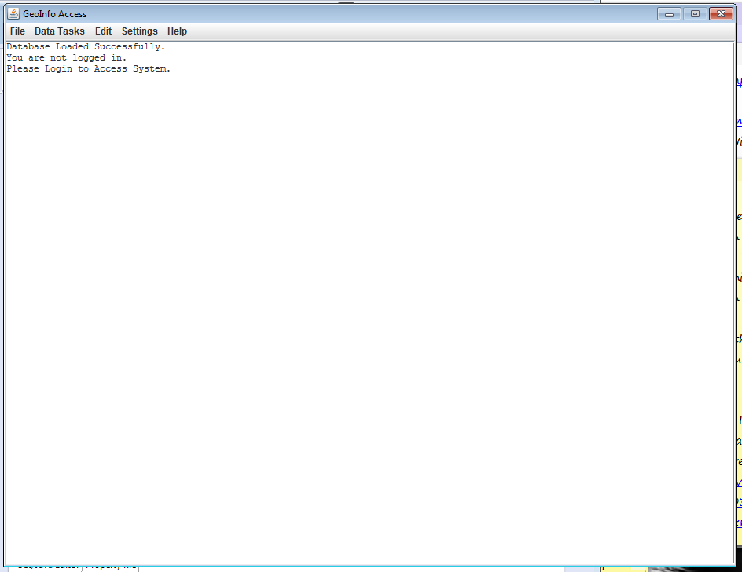a.) Start the application

b.) If it has started correctly than this screen will be displayed (see above).

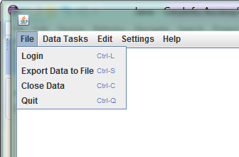

.

c.) Click on the file menu tab

d.) Click the login menu item.

e.) You can also click Ctrl-L to open the login dialogue.

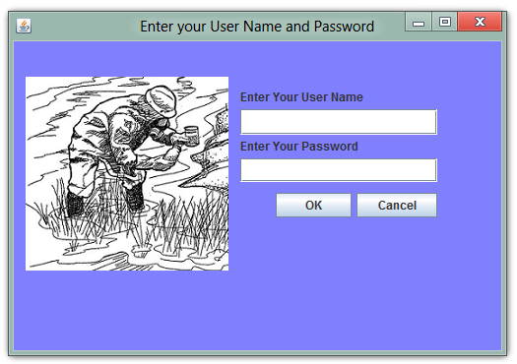

f.) Type in your username and password and click ok

An error message will appear if your username and/or password are incorrect

# Select Data Tasks



1. Go to the main window of GeoInfo Access
2. Click on the data tasks menu item
3. Select the task you wish the application to perform
4. It will display the ordered data in the main window
5. To find the survey data
   1. First use the Display a List of Survey Data
   2. Find the filename you are looking for
   3. Locate it on your computer
   4. Open in notepad

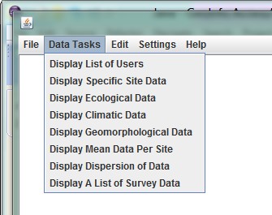

# C:\Users\Jason\Pictures\Screenshots\IT Project Help File\login.pngExport Data to File



1. Open the main window of GeoInfo Access
2. Click on the file menu
3. Click Export Data to file (Or Ctrl-S)

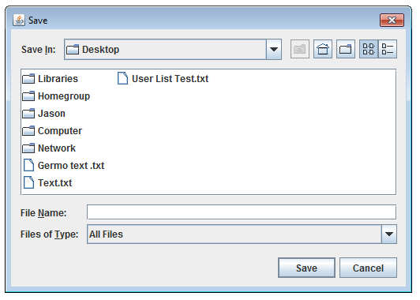

1. In the save dialogue find the directory in which you want the data to be saved
2. Type the file name AND extension (.txt) in
3. Press Save
4. A confirmation dialogue will appear if everything functioned correctly.

# Close Data



1. Click the file menu
2. Click Close Data
3. You Have to be logged in and also have data displayed

# Add Data

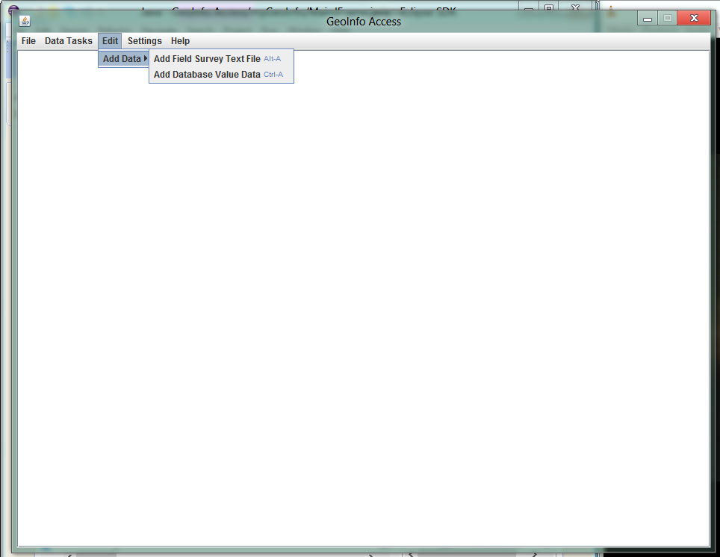

## Survey Data

1. Select the Add Field Survey Text File menu option (or click Alt-A)

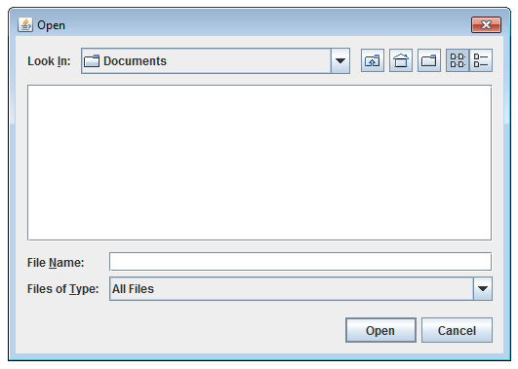

1. Use the open dialogue to select the survey file you wish to add to the system

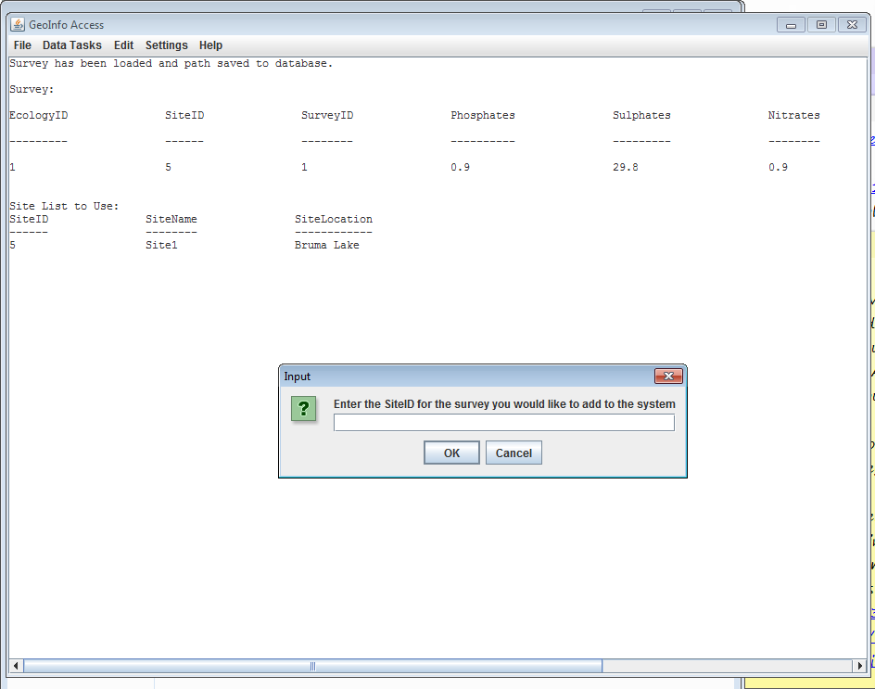

1. Above is a dialogue which opens asking you for the SiteID connected to the survey you are adding.
2. The survey you wish to add is displayed in the main window and underneath it is the Site List to use for the input dialogue.
3. Click ok and the Survey should be added to the system.

## Add Database Value Data

1. Go to the main window (The first picture in this section)
2. Click on the edit, add data menu options and select the add database value data option.

(Or click Ctrl-A)

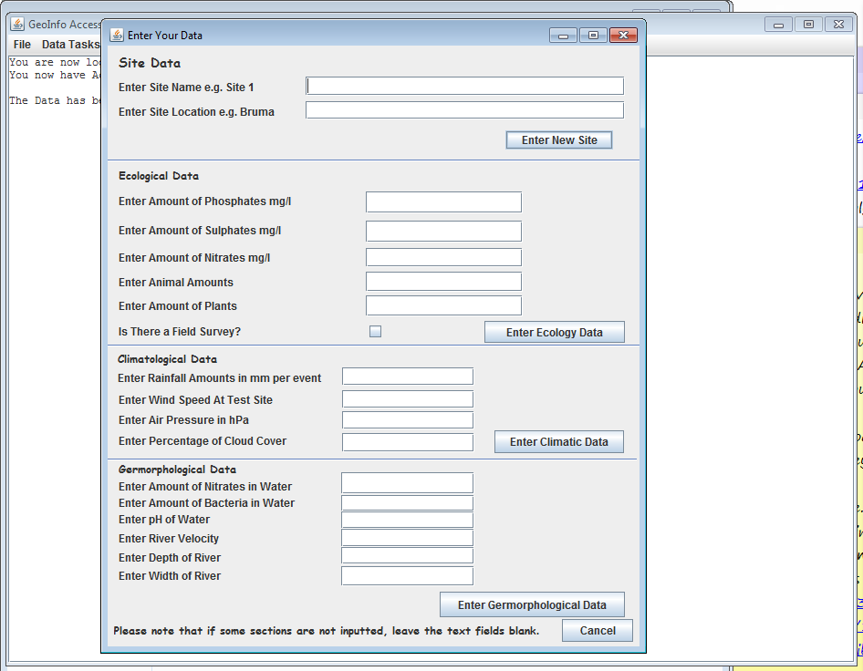

1. Enter the data from one of the sections. And press the button corresponding to that section.
2. It will then close the window and go back to the main window.
3. Do only one section at a time
4. For the Ecological, Climatological and Geomorphological data, when the data is entered a dialogue with the list of sites will appear. Use it for the next step.
5. After you close that dialogue another will appear asking for the SiteID required for the data you are inserting. Type in only the ID and click ok.
6. The Ecological section has extra dialogues pertaining to the survey if you checked it. If you did, it will ask for the survey id. You have to have firstly gone to the main window and called up the list of surveys from the data tasks section.
7. If the survey id you entered was incorrect it will assume the survey is not in the system and it will ask you to add it. It is almost the same method as used in the previous sub section of adding data.
8. Once that is done successfully the add data window will close and a message will be in the main window pertaining to adding data.
9. It will display a confirmation or an error depending on the success of the adding data process and the validity of the data you entered.

# Export User List To File

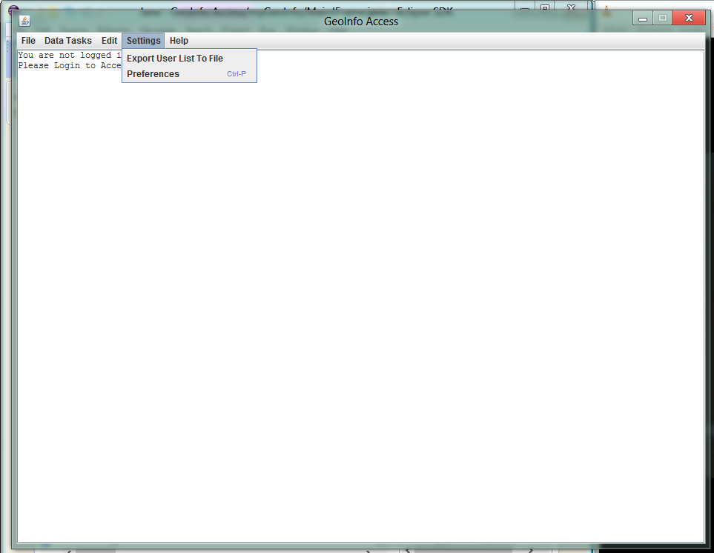

1. Go to the main window of GeoInfo Access
2. Click on the settings menu
3. Select Export User List to File



1. In the save dialogue find the directory in which you want the user list to be saved
2. Type the file name AND extension (.txt) in
3. Press Save
4. A confirmation dialogue will appear if everything functioned correctly.

# Preferences



1. To open the preferences window either click Ctrl-P or go to the main window, click the settings menu and select the preferences option.

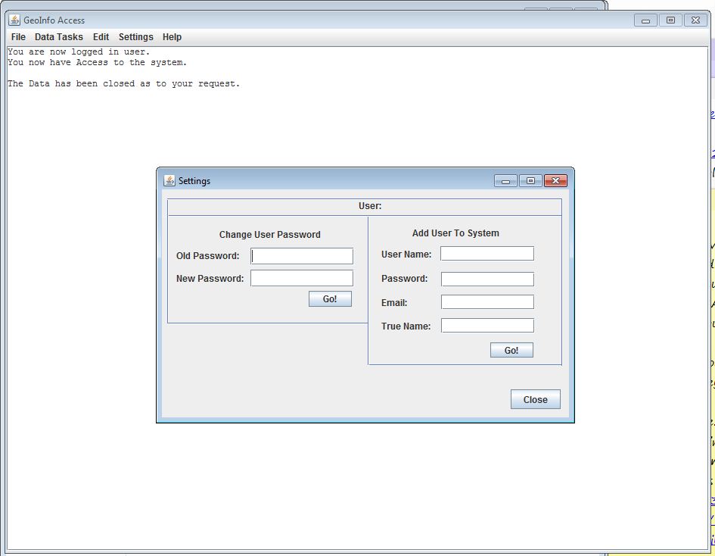

## Add a New User

1. To add a new user go to the section in the Settings window
2. Type in all the data of the new user
3. Click Go!
4. A confirmation dialogue will appear if everything functioned correctly

## Change the current user’s password

1. Go to the change user password section or the settings window
2. Type in the old password (ie current password) and the one you wish to have (New password) of the currently logged in user.
3. If the old password matches the current one than your password will change and a confirmation dialogue will appear else it will display an error dialogue.